SCD-LAB-09
22K-5195
1)
import jakarta.servlet.ServletException;
import jakarta.servlet.annotation.WebServlet;
import jakarta.servlet.http.HttpServlet;
import jakarta.servlet.http.HttpServletRequest;
import jakarta.servlet.http.HttpServletResponse;
import java.io.IOException;
import java.sql.Connection;
import java.sql.PreparedStatement;
import java.sql.ResultSet;
import java.sql.SQLException;
@WebServlet("/CreateAccountServlet")
public class CreateAccountServlet extends HttpServlet {
protected void doPost(HttpServletRequest request, HttpServletResponse response) throws ServletException, IOException {
String userID = request.getParameter("userID");
String email = request.getParameter("email");
String fullName = request.getParameter("fullName");
String password = request.getParameter("password");
String confirmPassword = request.getParameter("confirmPassword");
String dateOfBirth = request.getParameter("dateOfBirth");
if (!password.equals(confirmPassword)) {
request.setAttribute("error", "Passwords do not match.");
request.getRequestDispatcher("createAccount.jsp").forward(request, response);
return;
}
try (Connection conn = DatabaseUtil.getConnection();
PreparedStatement checkStmt = conn.prepareStatement("SELECT * FROM Users WHERE userID = ? OR email = ?")) {
checkStmt.setString(1, userID);
checkStmt.setString(2, email);
ResultSet rs = checkStmt.executeQuery();
if (rs.next()) {
request.setAttribute("error", "UserID or Email already exists.");
request.getRequestDispatcher("createAccount.jsp").forward(request, response);
return;
}
String hashedPassword = hashPassword(password); // Implement password hashing
PreparedStatement insertStmt = conn.prepareStatement(
"INSERT INTO Users (userID, email, fullName, password, dateOfBirth, role) " +
"VALUES (?, ?, ?, ?, TO_DATE(?, 'YYYY-MM-DD'), 'User')");
insertStmt.setString(1, userID);
insertStmt.setString(2, email);
insertStmt.setString(3, fullName);
insertStmt.setString(4, hashedPassword);
insertStmt.setString(5, dateOfBirth);
int rows = insertStmt.executeUpdate();
if (rows > 0) {
request.setAttribute("message", "Account created successfully!");
request.getRequestDispatcher("login.jsp").forward(request, response);
} else {
request.setAttribute("error", "Account creation failed.");
request.getRequestDispatcher("createAccount.jsp").forward(request, response);
}
} catch (SQLException | ClassNotFoundException e) {
e.printStackTrace();
request.setAttribute("error", "Database error. Please try again.");
request.getRequestDispatcher("createAccount.jsp").forward(request, response);
}
}
private String hashPassword(String password) {
return password; // Implement password hashing here
}
}

import jakarta.servlet.ServletException;
import jakarta.servlet.annotation.WebServlet;
import jakarta.servlet.http.HttpServlet;
import jakarta.servlet.http.HttpServletRequest;
import jakarta.servlet.http.HttpServletResponse;
import java.io.IOException;
import java.sql.Connection;
import java.sql.PreparedStatement;
import java.sql.SQLException;
import java.sql.Timestamp;
@WebServlet("/CreateUserServlet")
public class CreateUserServlet extends HttpServlet {
@Override
protected void doGet(HttpServletRequest request, HttpServletResponse response)
throws ServletException, IOException {
String role = (String) request.getSession().getAttribute("role");
// Only Super Admin can create new users
if (!"Super Admin".equals(role)) {
response.sendRedirect("unauthorized.jsp");
return;
}
// Forward to create user JSP
request.getRequestDispatcher("createUser.jsp").forward(request, response);
}
@Override
protected void doPost(HttpServletRequest request, HttpServletResponse response)
throws ServletException, IOException {
String userID = request.getParameter("userID");
String email = request.getParameter("email");
String fullName = request.getParameter("fullName");
String password = request.getParameter("password");
String role = request.getParameter("role");
try (Connection connection = DatabaseUtil.getConnection()) {
String query = "INSERT INTO Users (userID, email, fullName, password, role, created_at) VALUES (?, ?, ?, ?, ?, ?)";
try (PreparedStatement stmt = connection.prepareStatement(query)) {
stmt.setString(1, userID);
stmt.setString(2, email);
stmt.setString(3, fullName);
stmt.setString(4, password);
stmt.setString(5, role);
stmt.setTimestamp(6, new Timestamp(System.currentTimeMillis()));
int rowsInserted = stmt.executeUpdate();
if (rowsInserted > 0) {
request.setAttribute("message", "User created successfully.");
} else {
request.setAttribute("errorMessage", "User creation failed.");
}
}
} catch (SQLException | ClassNotFoundException e) {
e.printStackTrace();
request.setAttribute("errorMessage", "Database error: " + e.getMessage());
}
request.getRequestDispatcher("createUser.jsp").forward(request, response);
}
}

import java.sql.Connection;
import java.sql.DriverManager;
import java.sql.SQLException;
import java.util.Locale;
public class DatabaseUtil {
private static final String DB_URL = "jdbc:oracle:thin:@localhost:1521:xe";
private static final String DB_USER = "hani";
private static final String DB_PASS = "fast";
private static final String JDBC_DRIVER = "oracle.jdbc.driver.OracleDriver";
public static Connection getConnection() throws SQLException, ClassNotFoundException {
Locale.setDefault(Locale.US);
Class.forName(JDBC_DRIVER);
return DriverManager.getConnection(DB_URL, DB_USER, DB_PASS);
}
}

import jakarta.servlet.ServletException;
import jakarta.servlet.annotation.WebServlet;
import jakarta.servlet.http.*;
import java.io.IOException;
import java.sql.Connection;
import java.sql.PreparedStatement;
import java.sql.ResultSet;
import java.sql.SQLException;
@WebServlet("/LoginServlet")
public class LoginServlet extends HttpServlet {
protected void doPost(HttpServletRequest request, HttpServletResponse response) throws ServletException, IOException {
String email = request.getParameter("email");
String password = request.getParameter("password");
try (Connection conn = DatabaseUtil.getConnection();
PreparedStatement stmt = conn.prepareStatement("SELECT role, password FROM Users WHERE email = ?")) {
stmt.setString(1, email);
ResultSet rs = stmt.executeQuery();
if (rs.next()) {
String storedPassword = rs.getString("password");
String role = rs.getString("role");
if (storedPassword.equals(password)) {
HttpSession session = request.getSession();
session.setAttribute("role", role);
if ("Super Admin".equals(role)) {
response.sendRedirect("superAdminDashboard.jsp");
} else if ("Admin".equals(role)) {
response.sendRedirect("adminDashboard.jsp");
} else {
response.sendRedirect("userDashboard.jsp");
}
} else {
request.setAttribute("error", "Invalid password.");
request.getRequestDispatcher("login.jsp").forward(request, response);
}
} else {
request.setAttribute("error", "Email not found.");
request.getRequestDispatcher("login.jsp").forward(request, response);
}
} catch (SQLException | ClassNotFoundException e) {
e.printStackTrace();
request.setAttribute("error", "Database error.");
request.getRequestDispatcher("login.jsp").forward(request, response);
}
}
}

<%@ page session="true" %>
<%
String role = (String) session.getAttribute("role");
if (!"Admin".equals(role) && !"Super Admin".equals(role)) {
response.sendRedirect("unauthorized.jsp");
return;
}
%>
<html>
<head><title>Admin Dashboard</title></head>
<body>
<h2>Welcome, Admin!</h2>
<ul>
<li><a href="ManageUsersServlet">Manage Users</a></li>
</ul>
</body>
</html>

<%@ page language="java" contentType="text/html; charset=UTF-8" %>
<!DOCTYPE html>
<html>
<head>
<title>Create Account</title>
</head>
<body>
<h2>Create Account</h2>
<form action="CreateAccountServlet" method="post">
<label for="userID">User ID:</label>
<input type="text" name="userID" required><br>
<label for="email">Email:</label>
<input type="email" name="email" required><br>
<label for="fullName">Full Name:</label>
<input type="text" name="fullName" required><br>
<label for="password">Password:</label>
<input type="password" name="password" required><br>
<label for="confirmPassword">Confirm Password:</label>
<input type="password" name="confirmPassword" required><br>
<label for="dateOfBirth">Date of Birth:</label>
<input type="date" name="dateOfBirth"><br>
<input type="submit" value="Create Account">
</form>
<c:if test="${not empty error}">
<p style="color:red">${error}</p>
</c:if>
<c:if test="${not empty message}">
<p style="color:green">${message}</p>
</c:if>
</body>
</html>

<%@ page session="true" %>
<%
String role = (String) session.getAttribute("role");
if (!"Super Admin".equals(role)) {
response.sendRedirect("unauthorized.jsp");
return;
}
%>
<html>
<head><title>Create New User</title></head>
<body>
<h2>Create New User</h2>
<form action="CreateUserServlet" method="post">
User ID: <input type="text" name="userID" required><br>
Email: <input type="email" name="email" required><br>
Full Name: <input type="text" name="fullName" required><br>
Password: <input type="password" name="password" required><br>
Role:
<select name="role">
<option value="User">User</option>
<option value="Admin">Admin</option>
</select><br>
<button type="submit">Create User</button>
</form>
<%
if (request.getAttribute("message") != null) {
out.println("<p style='color:green;'>" + request.getAttribute("message") + "</p>");
}
if (request.getAttribute("errorMessage") != null) {
out.println("<p style='color:red;'>" + request.getAttribute("errorMessage") + "</p>");
}
%>
</body>
</html>

<%@ page language="java" contentType="text/html; charset=UTF-8" %>
<!DOCTYPE html>
<html>
<head>
<title>Login</title>
</head>
<body>
<h2>Login</h2>
<form action="LoginServlet" method="post">
<label for="email">Email:</label>
<input type="email" name="email" required><br>
<label for="password">Password:</label>
<input type="password" name="password" required><br>
<input type="submit" value="Login">
</form>
<c:if test="${not empty error}">
<p style="color:red">${error}</p>
</c:if>
</body>
</html>

<%@ page session="true" %>
<%
String role = (String) session.getAttribute("role");
if (!"Super Admin".equals(role)) {
response.sendRedirect("unauthorized.jsp");
return;
}
%>
<html>
<head><title>Super Admin Dashboard</title></head>
<body>
<h2>Welcome, Super Admin!</h2>
<ul>
<li><a href="CreateUserServlet">Create New User</a></li>
<li><a href="ManageUsersServlet">Manage Users</a></li>
<li><a href="ManageAdminsServlet">Manage Admins</a></li>
</ul>
</body>
</html>

<html>
<head><title>Unauthorized Access</title></head>
<body>
<h2>Access Denied</h2>
<p>You do not have permission to view this page.</p>
<a href="login.jsp">Return to Login</a>
</body>
</html>

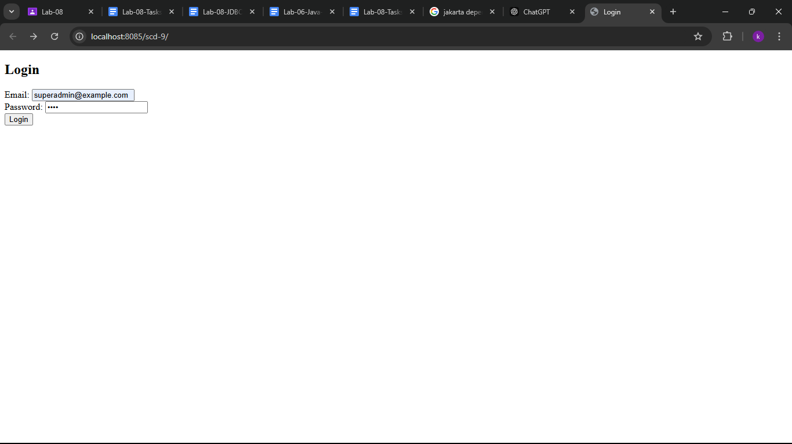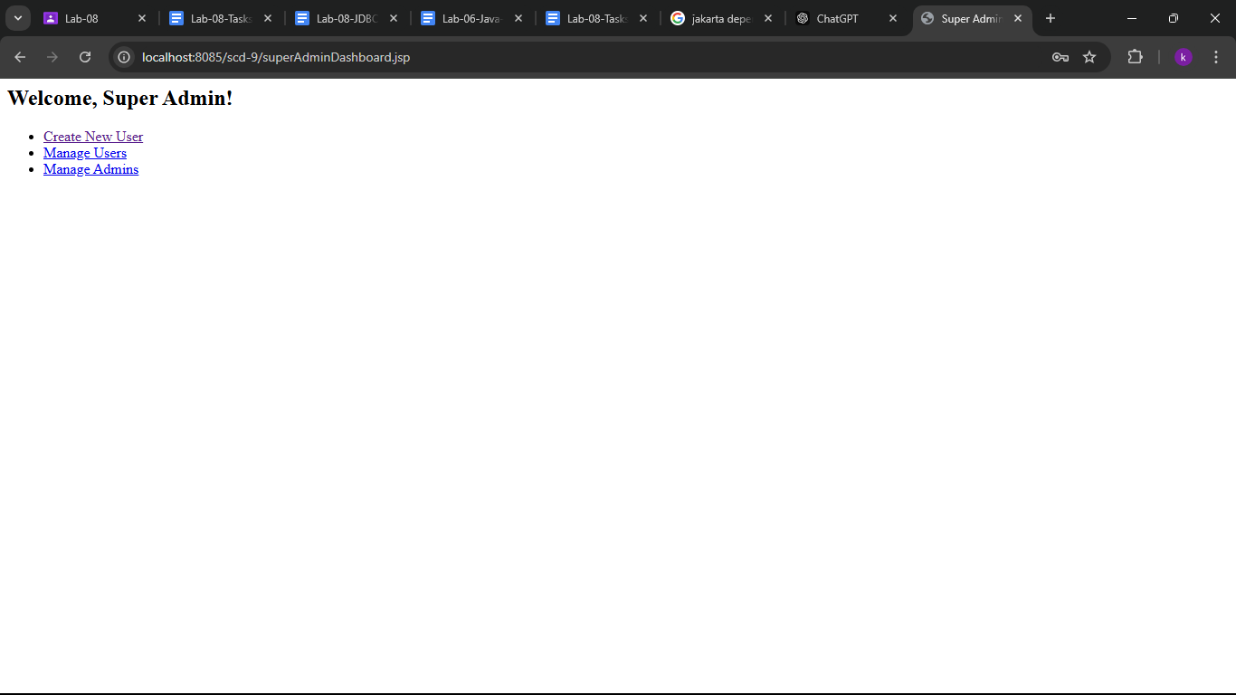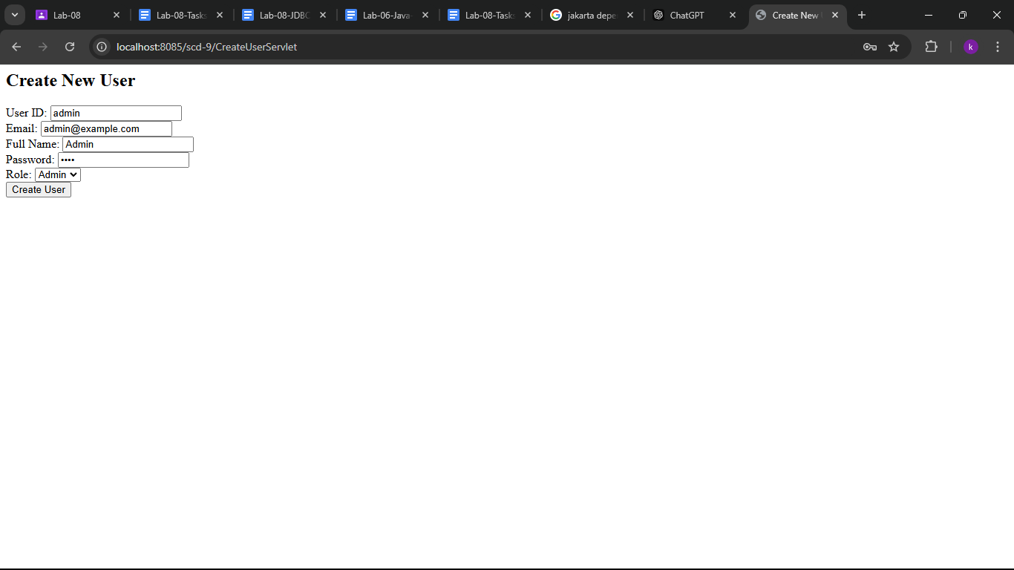
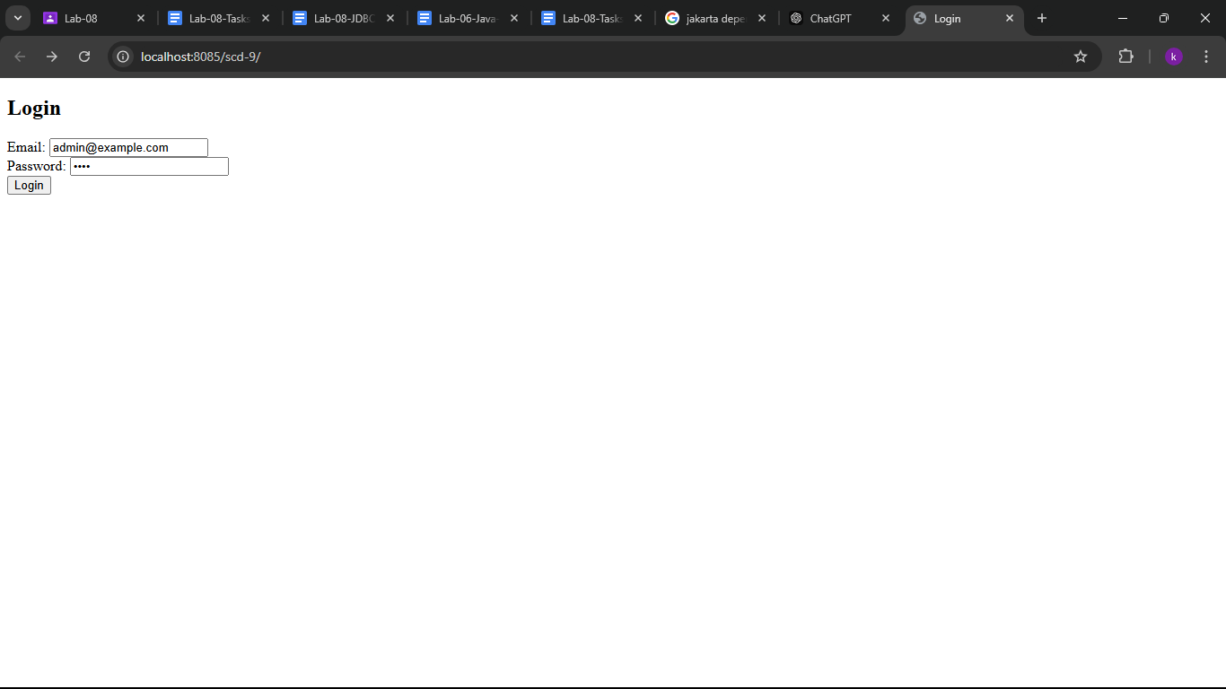
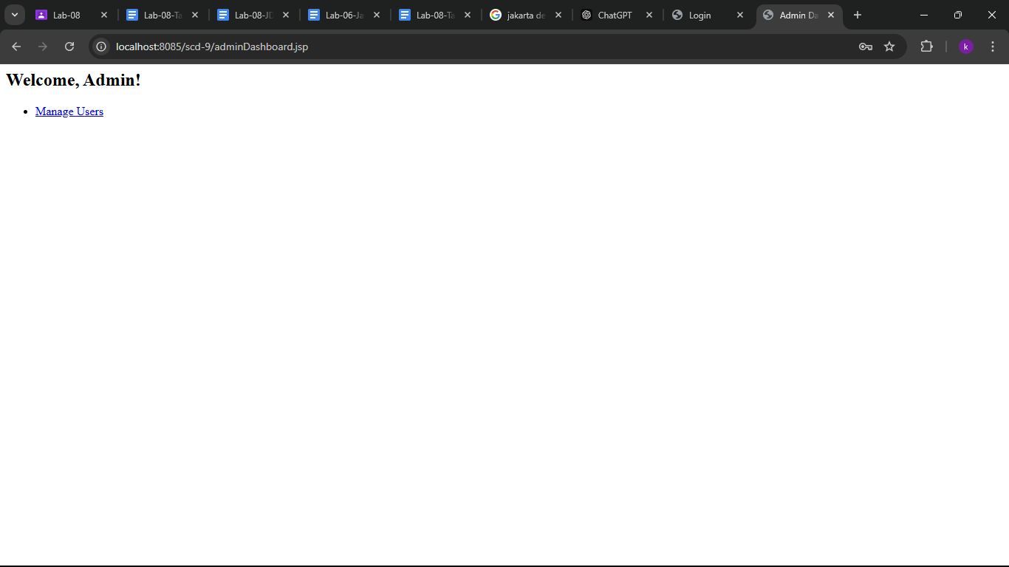
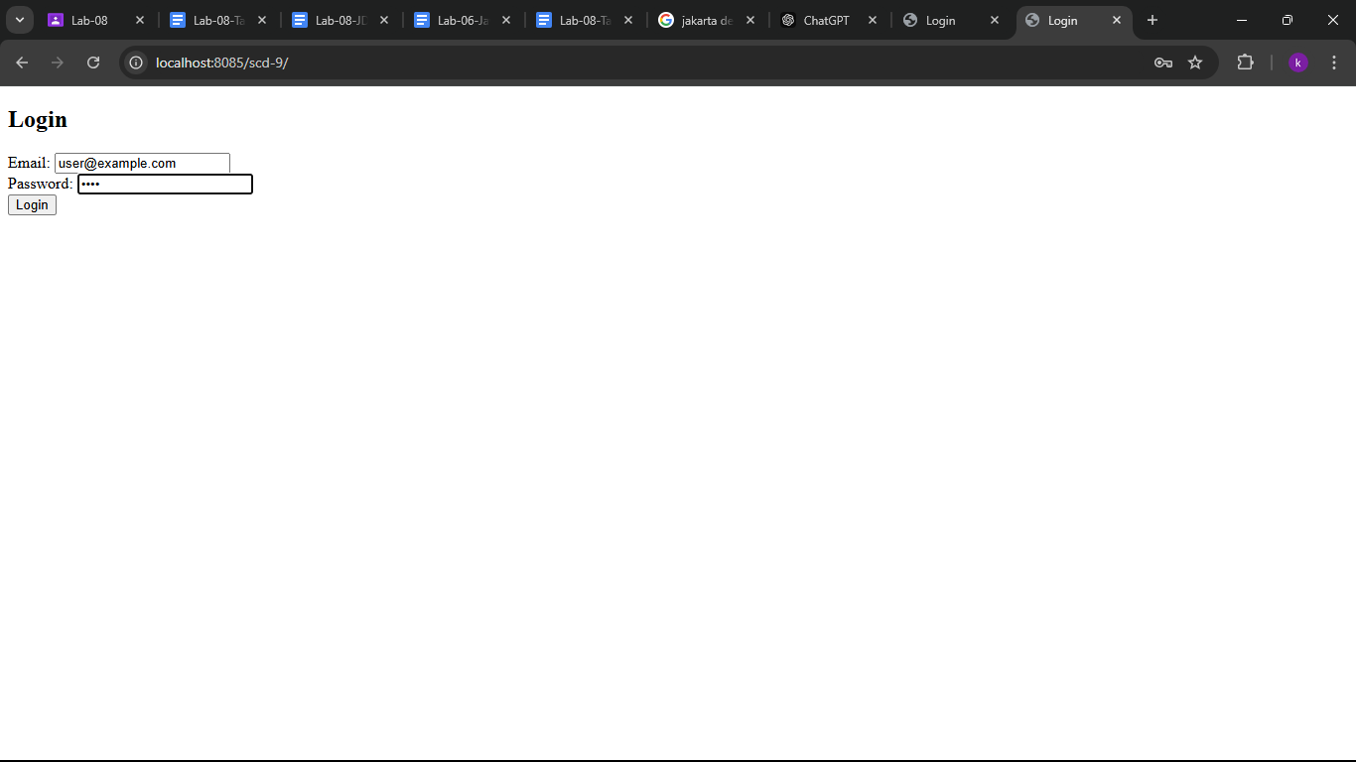
2)
public class Category {
private int categoryID;
private String categoryName;
// Constructor
public Category(int categoryID, String categoryName) {
this.categoryID = categoryID;
this.categoryName = categoryName;
}
// Getters and setters
public int getCategoryID() {
return categoryID;
}
public void setCategoryID(int categoryID) {
this.categoryID = categoryID;
}
public String getCategoryName() {
return categoryName;
}
public void setCategoryName(String categoryName) {
this.categoryName = categoryName;
}
}

import jakarta.servlet.*;
import jakarta.servlet.http.*;
import java.io.*;
import java.sql.*;
import java.util.List;
public class CategoryServlet extends HttpServlet {
// Handle HTTP GET requests
@Override
protected void doGet(HttpServletRequest request, HttpServletResponse response) throws ServletException, IOException {
String action = request.getParameter("action");
// If the action is to delete a category
if ("delete".equals(action)) {
int categoryID = Integer.parseInt(request.getParameter("id"));
deleteCategory(categoryID);
response.sendRedirect("categoryList.jsp");
} else {
// Retrieve categories from the database and forward to category list page
List<Category> categories = getCategories();
request.setAttribute("categories", categories);
RequestDispatcher dispatcher = request.getRequestDispatcher("categoryList.jsp");
dispatcher.forward(request, response);
}
}
// Handle HTTP POST requests for adding or editing categories
@Override
protected void doPost(HttpServletRequest request, HttpServletResponse response) throws ServletException, IOException {
String action = request.getParameter("action");
if ("add".equals(action)) {
String categoryName = request.getParameter("categoryName");
addCategory(categoryName);
response.sendRedirect("categoryList.jsp");
} else if ("edit".equals(action)) {
int categoryID = Integer.parseInt(request.getParameter("categoryID"));
String categoryName = request.getParameter("categoryName");
updateCategory(categoryID, categoryName);
response.sendRedirect("categoryList.jsp");
}
}
// Method to retrieve categories from the database
private List<Category> getCategories() {
List<Category> categories = null;
try (Connection connection = DatabaseUtil.getConnection();
Statement stmt = connection.createStatement();
ResultSet rs = stmt.executeQuery("SELECT * FROM Categories")) {
while (rs.next()) {
Category category = new Category(rs.getInt("categoryID"), rs.getString("categoryName"));
categories.add(category);
}
} catch (SQLException e) {
e.printStackTrace();
} catch (ClassNotFoundException e) {
throw new RuntimeException(e);
}
return categories;
}
// Method to add a new category
private void addCategory(String categoryName) {
try (Connection connection = DatabaseUtil.getConnection();
PreparedStatement stmt = connection.prepareStatement("INSERT INTO Categories (categoryName) VALUES (?)")) {
stmt.setString(1, categoryName);
stmt.executeUpdate();
} catch (SQLException | ClassNotFoundException e) {
e.printStackTrace();
}
}
// Method to update an existing category
private void updateCategory(int categoryID, String categoryName) {
try (Connection connection = DatabaseUtil.getConnection();
PreparedStatement stmt = connection.prepareStatement("UPDATE Categories SET categoryName = ? WHERE categoryID = ?")) {
stmt.setString(1, categoryName);
stmt.setInt(2, categoryID);
stmt.executeUpdate();
} catch (SQLException | ClassNotFoundException e) {
e.printStackTrace();
}
}
// Method to delete a category
private void deleteCategory(int categoryID) {
try (Connection connection = DatabaseUtil.getConnection();
PreparedStatement stmt = connection.prepareStatement("DELETE FROM Categories WHERE categoryID = ?")) {
stmt.setInt(1, categoryID);
stmt.executeUpdate();
} catch (SQLException | ClassNotFoundException e) {
e.printStackTrace();
}
}
}

public class Item {
private int itemID;
private String itemName;
private int categoryID;
private double price;
private int stock;
// Constructor
public Item(int itemID, String itemName, int categoryID, double price, int stock) {
this.itemID = itemID;
this.itemName = itemName;
this.categoryID = categoryID;
this.price = price;
this.stock = stock;
}
// Getters and setters
public int getItemID() {
return itemID;
}
public void setItemID(int itemID) {
this.itemID = itemID;
}
public String getItemName() {
return itemName;
}
public void setItemName(String itemName) {
this.itemName = itemName;
}
public int getCategoryID() {
return categoryID;
}
public void setCategoryID(int categoryID) {
this.categoryID = categoryID;
}
public double getPrice() {
return price;
}
public void setPrice(double price) {
this.price = price;
}
public int getStock() {
return stock;
}
public void setStock(int stock) {
this.stock = stock;
}
}

import jakarta.servlet.*;
import jakarta.servlet.http.*;
import java.io.*;
import java.sql.*;
import java.util.List;
public class ItemServlet extends HttpServlet {
// Handle HTTP GET requests
@Override
protected void doGet(HttpServletRequest request, HttpServletResponse response) throws ServletException, IOException {
String action = request.getParameter("action");
// If the action is to delete an item
if ("delete".equals(action)) {
int itemID = Integer.parseInt(request.getParameter("id"));
deleteItem(itemID);
response.sendRedirect("itemList.jsp");
} else {
// Retrieve items from the database and forward to item list page
List<Item> items = getItems();
request.setAttribute("items", items);
RequestDispatcher dispatcher = request.getRequestDispatcher("itemList.jsp");
dispatcher.forward(request, response);
}
}
// Handle HTTP POST requests for adding or editing items
@Override
protected void doPost(HttpServletRequest request, HttpServletResponse response) throws ServletException, IOException {
String action = request.getParameter("action");
if ("add".equals(action)) {
String itemName = request.getParameter("itemName");
int categoryID = Integer.parseInt(request.getParameter("categoryID"));
double price = Double.parseDouble(request.getParameter("price"));
int stock = Integer.parseInt(request.getParameter("stock"));
addItem(itemName, categoryID, price, stock);
response.sendRedirect("itemList.jsp");
} else if ("edit".equals(action)) {
int itemID = Integer.parseInt(request.getParameter("itemID"));
String itemName = request.getParameter("itemName");
int categoryID = Integer.parseInt(request.getParameter("categoryID"));
double price = Double.parseDouble(request.getParameter("price"));
int stock = Integer.parseInt(request.getParameter("stock"));
updateItem(itemID, itemName, categoryID, price, stock);
response.sendRedirect("itemList.jsp");
}
}
// Method to retrieve items from the database
private List<Item> getItems() {
List<Item> items = null;
try (Connection connection = DatabaseUtil.getConnection();
Statement stmt = connection.createStatement();
ResultSet rs = stmt.executeQuery("SELECT I.itemID, I.itemName, I.price, I.stock, C.categoryID FROM Items I JOIN Categories C ON I.categoryID = C.categoryID")) {
while (rs.next()) {
Item item = new Item(
rs.getInt("itemID"),
rs.getString("itemName"),
rs.getInt("categoryID"),
rs.getDouble("price"),
rs.getInt("stock"));
items.add(item);
}
} catch (SQLException | ClassNotFoundException e) {
e.printStackTrace();
}
return items;
}
// Method to add a new item
private void addItem(String itemName, int categoryID, double price, int stock) {
try (Connection connection = DatabaseUtil.getConnection();
PreparedStatement stmt = connection.prepareStatement("INSERT INTO Items (itemName, categoryID, price, stock) VALUES (?, ?, ?, ?)")) {
stmt.setString(1, itemName);
stmt.setInt(2, categoryID);
stmt.setDouble(3, price);
stmt.setInt(4, stock);
stmt.executeUpdate();
} catch (SQLException | ClassNotFoundException e) {
e.printStackTrace();
}
}
// Method to update an existing item
private void updateItem(int itemID, String itemName, int categoryID, double price, int stock) {
try (Connection connection = DatabaseUtil.getConnection();
PreparedStatement stmt = connection.prepareStatement("UPDATE Items SET itemName = ?, categoryID = ?, price = ?, stock = ? WHERE itemID = ?")) {
stmt.setString(1, itemName);
stmt.setInt(2, categoryID);
stmt.setDouble(3, price);
stmt.setInt(4, stock);
stmt.setInt(5, itemID);
stmt.executeUpdate();
} catch (SQLException | ClassNotFoundException e) {
e.printStackTrace();
}
}
// Method to delete an item
private void deleteItem(int itemID) {
try (Connection connection = DatabaseUtil.getConnection();
PreparedStatement stmt = connection.prepareStatement("DELETE FROM Items WHERE itemID = ?")) {
stmt.setInt(1, itemID);
stmt.executeUpdate();
} catch (SQLException | ClassNotFoundException e) {
e.printStackTrace();
}
}
}
<%@ page contentType="text/html;charset=UTF-8" language="java" %>
<!DOCTYPE html>
<html lang="en">
<head>
<meta charset="UTF-8">
<meta http-equiv="X-UA-Compatible" content="IE=edge">
<meta name="viewport" content="width=device-width, initial-scale=1.0">
<title>Category List</title>
<link rel="stylesheet" href="styles.css">
</head>
<body>
<h1>Manage Categories</h1>
<a href="addCategory.jsp">Add New Category</a>
<table border="1">
<thead>
<tr>
<th>Category ID</th>
<th>Category Name</th>
<th>Actions</th>
</tr>
</thead>
<tbody>
<c:forEach var="category" items="${categories}">
<tr>
<td>${category.categoryID}</td>
<td>${category.categoryName}</td>
<td>
<a href="editCategory.jsp?id=${category.categoryID}">Edit</a> |
<a href="CategoryServlet?action=delete&id=${category.categoryID}" onclick="return confirm('Are you sure you want to delete this category?')">Delete</a>
</td>
</tr>
</c:forEach>
</tbody>
</table>
</body>
</html>

<%@ page contentType="text/html;charset=UTF-8" language="java" %>
<!DOCTYPE html>
<html lang="en">
<head>
<meta charset="UTF-8">
<meta http-equiv="X-UA-Compatible" content="IE=edge">
<meta name="viewport" content="width=device-width, initial-scale=1.0">
<title>Item List</title>
<link rel="stylesheet" href="styles.css">
</head>
<body>
<h1>Manage Items</h1>
<a href="addItem.jsp">Add New Item</a>
<table border="1">
<thead>
<tr>
<th>Item ID</th>
<th>Item Name</th>
<th>Category</th>
<th>Price</th>
<th>Stock</th>
<th>Actions</th>
</tr>
</thead>
<tbody>
<c:forEach var="item" items="${items}">
<tr>
<td>${item.itemID}</td>
<td>${item.itemName}</td>
<td>${item.categoryName}</td>
<td>${item.price}</td>
<td>${item.stock}</td>
<td>
<a href="editItem.jsp?id=${item.itemID}">Edit</a> |
<a href="ItemServlet?action=delete&id=${item.itemID}" onclick="return confirm('Are you sure you want to delete this item?')">Delete</a>
</td>
</tr>
</c:forEach>
</tbody>
</table>
</body>
</html>

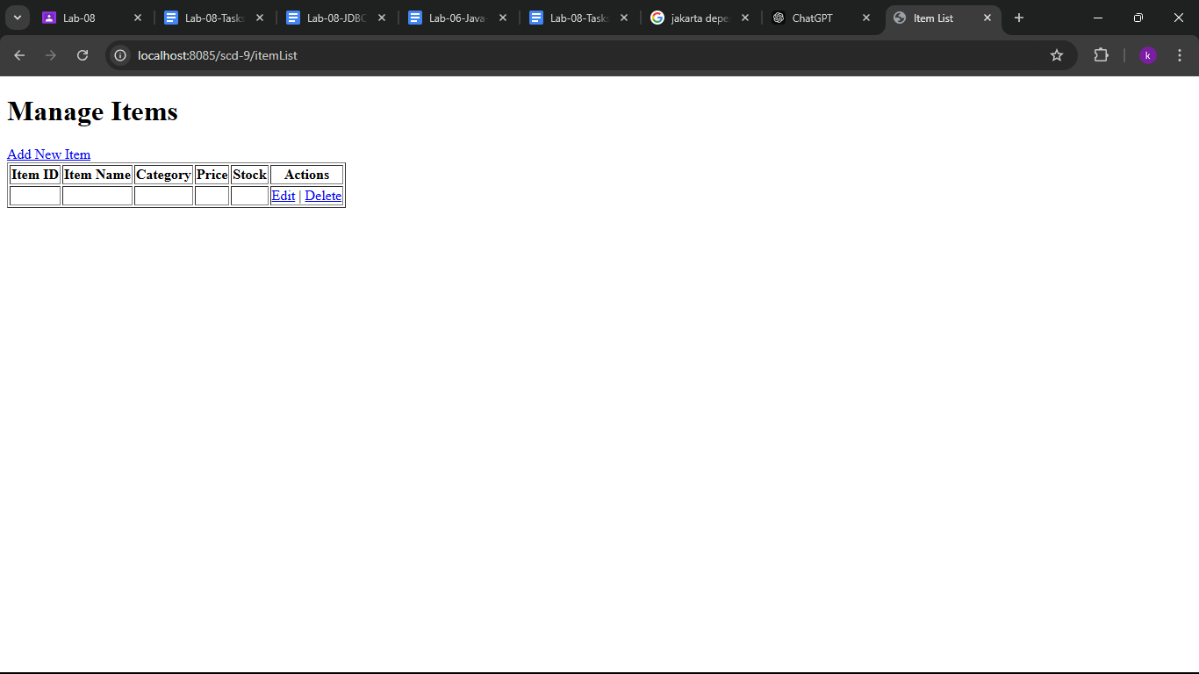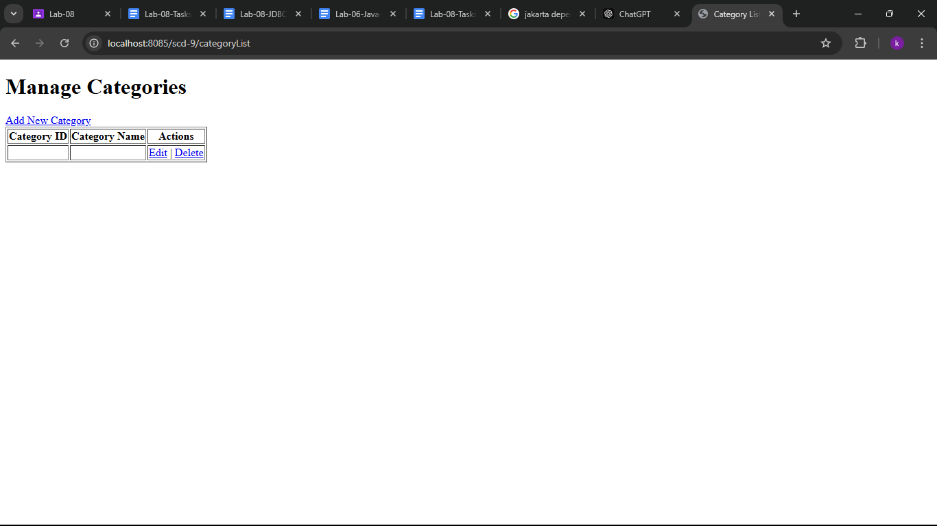

3)
import jakarta.servlet.*;
import jakarta.servlet.http.*;
import java.io.*;
import java.sql.*;
public class PlaceOrderServlet extends HttpServlet {
protected void doGet(HttpServletRequest request, HttpServletResponse response) throws ServletException, IOException {
String itemIDStr = request.getParameter("itemID");
String quantityStr = request.getParameter("quantity");
if (itemIDStr == null || itemIDStr.isEmpty()) {
response.sendError(HttpServletResponse.SC_BAD_REQUEST, "Item ID is missing.");
return;
}
if (quantityStr == null || quantityStr.isEmpty()) {
response.sendError(HttpServletResponse.SC_BAD_REQUEST, "Quantity is missing.");
return;
}
int itemID = 0;
int quantity = 0;
try {
itemID = Integer.parseInt(itemIDStr);
} catch (NumberFormatException e) {
response.sendError(HttpServletResponse.SC_BAD_REQUEST, "Invalid item ID.");
return;
}
// Try to parse quantity
try {
quantity = Integer.parseInt(quantityStr);
} catch (NumberFormatException e) {
response.sendError(HttpServletResponse.SC_BAD_REQUEST, "Invalid quantity.");
return;
}
Connection conn = null;
PreparedStatement pst = null;
ResultSet rs = null;
try {
// Set up database connection (adjust connection details as needed)
conn = DriverManager.getConnection("jdbc:oracle:thin:@localhost:1521:xe", "username", "password");
String checkItemSQL = "SELECT stock FROM Items WHERE itemID = ?";
pst = conn.prepareStatement(checkItemSQL);
pst.setInt(1, itemID);
rs = pst.executeQuery();
if (!rs.next()) {
response.sendError(HttpServletResponse.SC_BAD_REQUEST, "Item not found.");
return;
}
// Get the stock available for the item
int availableStock = rs.getInt("stock");
// Check if enough stock is available
if (availableStock < quantity) {
response.sendError(HttpServletResponse.SC_BAD_REQUEST, "Not enough stock available.");
return;
}
// Place the order
String insertOrderSQL = "INSERT INTO Orders (userID, itemID, quantity, orderStatus, paymentMethod) VALUES (?, ?, ?, 'Pending', 'Cash on Delivery')";
pst = conn.prepareStatement(insertOrderSQL);
pst.setInt(1, 1); // Example: userID = 1 (you'll replace this with actual logged-in user's ID)
pst.setInt(2, itemID);
pst.setInt(3, quantity);
int result = pst.executeUpdate();
if (result > 0) {
// Update the stock in the Items table
String updateStockSQL = "UPDATE Items SET stock = stock - ? WHERE itemID = ?";
pst = conn.prepareStatement(updateStockSQL);
pst.setInt(1, quantity);
pst.setInt(2, itemID);
pst.executeUpdate();
// Successful order placement
response.getWriter().write("Order placed successfully.");
} else {
response.sendError(HttpServletResponse.SC_INTERNAL_SERVER_ERROR, "Failed to place order.");
}
} catch (SQLException e) {
e.printStackTrace();
response.sendError(HttpServletResponse.SC_INTERNAL_SERVER_ERROR, "Database error.");
} finally {
// Close resources
try {
if (rs != null) rs.close();
if (pst != null) pst.close();
if (conn != null) conn.close();
} catch (SQLException e) {
e.printStackTrace();
}
}
}
}

<%@ page contentType="text/html;charset=UTF-8" language="java" %>
<%@ taglib uri="http://java.sun.com/jsp/jstl/core" prefix="c" %>
<!DOCTYPE html>
<html lang="en">
<head>
<meta charset="UTF-8">
<meta name="viewport" content="width=device-width, initial-scale=1.0">
<title>Catalog</title>
</head>
<body>
<h2>Catalog of Items</h2>
<!-- Hardcoding item details -->
<c:set var="item1" value="{ 'id': 1, 'name': 'Pizza', 'category': 'Main Course', 'price': 10.99, 'stock': 50, 'image': 'pizza.jpg' }" />
<c:set var="item2" value="{ 'id': 2, 'name': 'Burger', 'category': 'Fast Food', 'price': 5.99, 'stock': 100, 'image': 'burger.jpg' }" />
<c:set var="item3" value="{ 'id': 3, 'name': 'Pasta', 'category': 'Main Course', 'price': 8.99, 'stock': 30, 'image': 'pasta.jpg' }" />
<c:set var="item4" value="{ 'id': 4, 'name': 'Salad', 'category': 'Appetizers', 'price': 4.99, 'stock': 60, 'image': 'salad.jpg' }" />
<!-- Store items in a list -->
<c:set var="items" value="${item1},${item2},${item3},${item4}" />
<!-- Iterate over the hardcoded items -->
<c:forEach var="item" items="${items}">
<div>
<h3>${item.name}</h3>
<p>Category: ${item.category}</p>
<p>Price: $${item.price}</p>
<p>Stock: ${item.stock}</p>
<c:if test="${not empty item.image}">
<img src="${item.image}" alt="Image of ${item.name}" width="100" />
</c:if>
<form action="PlaceOrderServlet" method="post">
<input type="hidden" name="itemId" value="${item.id}" />
<button type="submit">Order</button>
</form>
</div>
</c:forEach>
</body>
</html>

<%@ page contentType="text/html;charset=UTF-8" language="java" %>
<!DOCTYPE html>
<html lang="en">
<head>
<meta charset="UTF-8">
<meta name="viewport" content="width=device-width, initial-scale=1.0">
<title>Login</title>
</head>
<body>
<h2>Login</h2>
<form action="LoginServlet" method="post">
<label for="email">Email:</label>
<input type="email" id="email" name="email" required /><br><br>
<label for="password">Password:</label>
<input type="password" id="password" name="password" required /><br><br>
<button type="submit">Login</button>
</form>
<a href="createAccount.jsp">Create an Account</a>
</body>
</html>
<%@ page contentType="text/html;charset=UTF-8" language="java" %>
<!DOCTYPE html>
<html lang="en">
<head>
<meta charset="UTF-8">
<meta name="viewport" content="width=device-width, initial-scale=1.0">
<title>Order Confirmation</title>
</head>
<body>
<h2>Order Confirmation</h2>
<c:set var="orderId" value="12345" />
<c:set var="orderStatus" value="Pending" />
<c:set var="paymentMethod" value="Cash on Delivery" />
<p>Your order has been placed successfully!</p>
<p>Order ID: ${orderId}</p>
<p>Order Status: ${orderStatus}</p>
<p>Payment Method: ${paymentMethod}</p>
<a href="catalog.jsp">Back to Catalog</a>
</body>
</html>

import jakarta.servlet.*;
import jakarta.servlet.http.*;
import java.io.*;
import java.util.*;
public class CatalogServlet extends HttpServlet {
@Override
protected void doGet(HttpServletRequest request, HttpServletResponse response) throws ServletException, IOException {
List<Map<String, String>> categories = new ArrayList<>();
Map<String, String> category1 = new HashMap<>();
category1.put("id", "1");
category1.put("name", "Main Course");
categories.add(category1);
Map<String, String> category2 = new HashMap<>();
category2.put("id", "2");
category2.put("name", "Fast Food");
categories.add(category2);
Map<String, String> category3 = new HashMap<>();
category3.put("id", "3");
category3.put("name", "Appetizers");
categories.add(category3);
// Set categories as a request attribute
request.setAttribute("categories", categories);
// Forward request to categoryList.jsp
RequestDispatcher dispatcher = request.getRequestDispatcher("/categoryList.jsp");
dispatcher.forward(request, response);
}
}

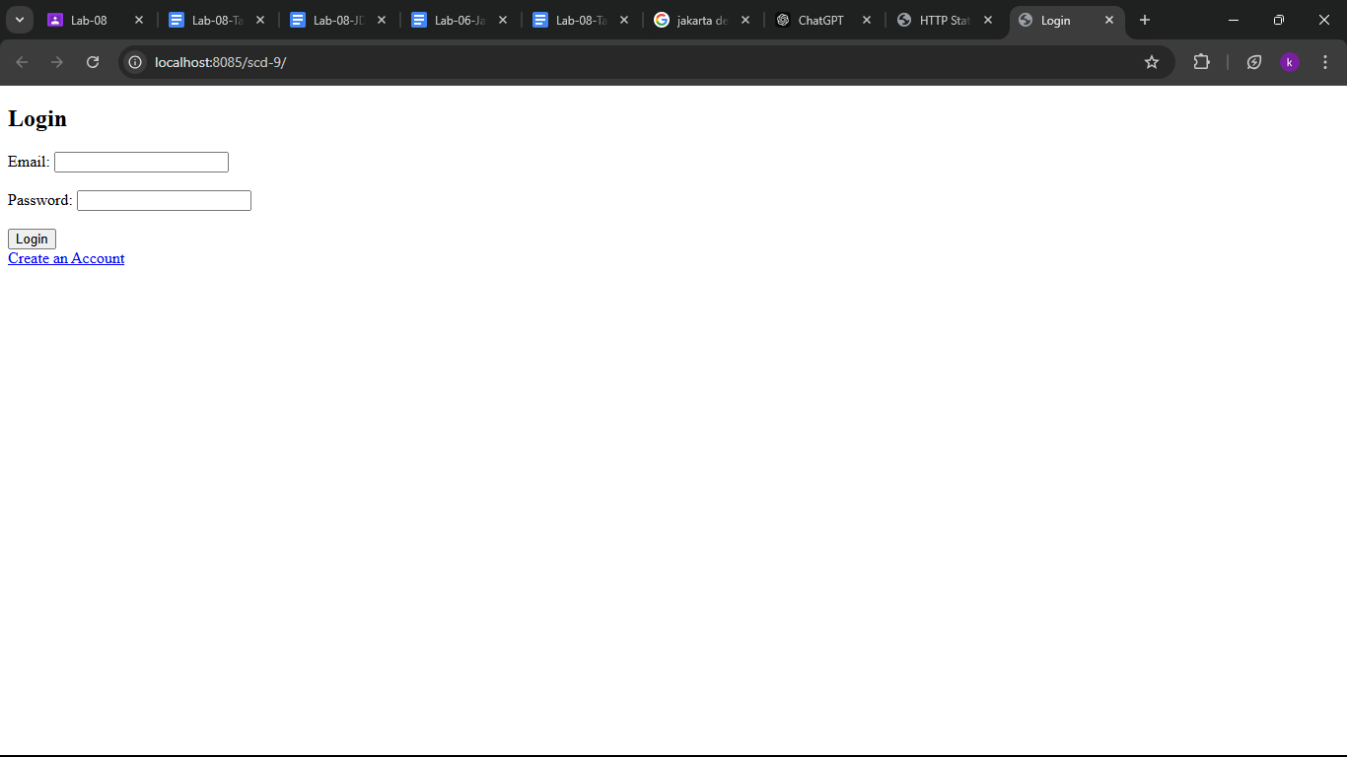
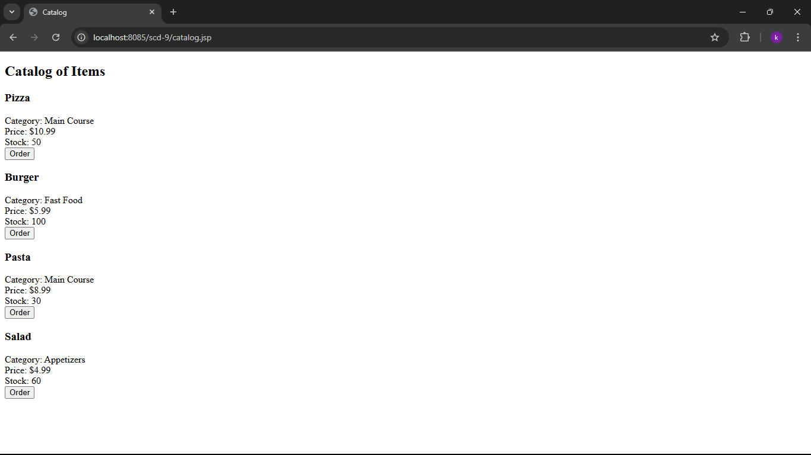
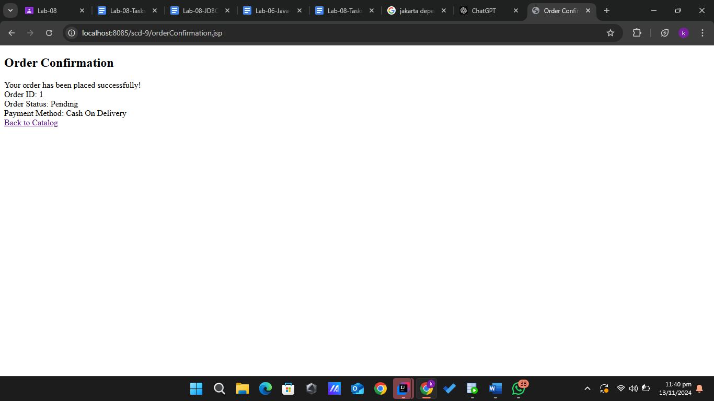

4)
import javax.servlet.*;
import javax.servlet.http.*;
import java.io.*;
import java.sql.*;
public class UpdateOrderServlet extends HttpServlet {
protected void doPost(HttpServletRequest request, HttpServletResponse response) throws ServletException, IOException {
String orderId = request.getParameter("orderId");
String status = request.getParameter("status");
// Connect to the database and update the order status
try (Connection conn = DriverManager.getConnection("jdbc:oracle:thin:@localhost:1521:xe", "username", "password")) {
String sql = "UPDATE Orders SET status = ? WHERE order_id = ?";
try (PreparedStatement stmt = conn.prepareStatement(sql)) {
stmt.setString(1, status);
stmt.setString(2, orderId);
int rowsAffected = stmt.executeUpdate();
if (rowsAffected > 0 && "Completed".equals(status)) {
// Reduce stock levels when order is completed
// Assume `reduceStockForOrder` method handles inventory update
reduceStockForOrder(orderId, conn);
}
response.sendRedirect("adminOrderManagement.jsp");
}
} catch (SQLException e) {
e.printStackTrace();
response.sendError(HttpServletResponse.SC_INTERNAL_SERVER_ERROR, "Database error");
}
}
private void reduceStockForOrder(String orderId, Connection conn) throws SQLException {
String sql = "SELECT item_id, quantity FROM Order_Items WHERE order_id = ?";
try (PreparedStatement stmt = conn.prepareStatement(sql)) {
stmt.setString(1, orderId);
ResultSet rs = stmt.executeQuery();
while (rs.next()) {
int itemId = rs.getInt("item_id");
int quantity = rs.getInt("quantity");
// Reduce stock for each item in the order
String updateStockSql = "UPDATE Items SET stock = stock - ? WHERE item_id = ?";
try (PreparedStatement updateStmt = conn.prepareStatement(updateStockSql)) {
updateStmt.setInt(1, quantity);
updateStmt.setInt(2, itemId);
updateStmt.executeUpdate();
}
}
}
}
}

import javax.servlet.*;
import javax.servlet.http.*;
import java.io.*;
import java.sql.*;
public class TrackOrderServlet extends HttpServlet {
protected void doGet(HttpServletRequest request, HttpServletResponse response) throws ServletException, IOException {
String orderId = request.getParameter("orderId");
String orderStatus = null;
// Fetch the order status from the database based on the order ID
try (Connection conn = DriverManager.getConnection("jdbc:oracle:thin:@localhost:1521:xe", "username", "password")) {
String sql = "SELECT status FROM Orders WHERE order_id = ?";
try (PreparedStatement stmt = conn.prepareStatement(sql)) {
stmt.setString(1, orderId);
ResultSet rs = stmt.executeQuery();
if (rs.next()) {
orderStatus = rs.getString("status");
}
request.setAttribute("orderStatus", orderStatus);
request.getRequestDispatcher("userTrackOrder.jsp").forward(request, response);
}
} catch (SQLException e) {
e.printStackTrace();
response.sendError(HttpServletResponse.SC_INTERNAL_SERVER_ERROR, "Database error");
}
}
}

import javax.servlet.*;
import javax.servlet.http.*;
import java.io.*;
import java.sql.*;
public class UpdateProfileServlet extends HttpServlet {
protected void doPost(HttpServletRequest request, HttpServletResponse response) throws ServletException, IOException {
String name = request.getParameter("name");
String password = request.getParameter("password");
String confirmPassword = request.getParameter("confirmPassword");
HttpSession session = request.getSession();
String userId = (String) session.getAttribute("userId"); // Assuming user ID is stored in the session
if (password != null && !password.equals(confirmPassword)) {
response.sendError(HttpServletResponse.SC_BAD_REQUEST, "Passwords do not match");
return;
}
try (Connection conn = DriverManager.getConnection("jdbc:oracle:thin:@localhost:1521:xe", "username", "password")) {
String sql = "UPDATE Users SET name = ?, password = ? WHERE user_id = ?";
try (PreparedStatement stmt = conn.prepareStatement(sql)) {
stmt.setString(1, name);
if (password != null && !password.isEmpty()) {
stmt.setString(2, password); // You should hash the password before storing
}
stmt.setString(3, userId);
int rowsAffected = stmt.executeUpdate();
if (rowsAffected > 0) {
response.sendRedirect("userProfileManagement.jsp");
} else {
response.sendError(HttpServletResponse.SC_INTERNAL_SERVER_ERROR, "Failed to update profile");
}
}
} catch (SQLException e) {
e.printStackTrace();
response.sendError(HttpServletResponse.SC_INTERNAL_SERVER_ERROR, "Database error");
}
}
}

<%@ page contentType="text/html;charset=UTF-8" language="java" %>
<!DOCTYPE html>
<html lang="en">
<head>
<meta charset="UTF-8">
<meta name="viewport" content="width=device-width, initial-scale=1.0">
<title>Admin Order Management</title>
</head>
<body>
<h2>Admin - Manage Orders</h2>
<table border="1">
<thead>
<tr>
<th>Order ID</th>
<th>User ID</th>
<th>Order Date</th>
<th>Status</th>
<th>Update Status</th>
</tr>
</thead>
<tbody>
<!-- Hardcoded Orders for Demo -->
<tr>
<td>1001</td>
<td>501</td>
<td>2024-11-13 10:00 AM</td>
<td>Pending</td>
<td>
<form action="UpdateOrderServlet" method="post">
<input type="hidden" name="orderId" value="1001" />
<select name="status">
<option value="Pending">Pending</option>
<option value="Processed">Processed</option>
<option value="Completed">Completed</option>
</select>
<button type="submit">Update</button>
</form>
</td>
</tr>
<tr>
<td>1002</td>
<td>502</td>
<td>2024-11-13 10:30 AM</td>
<td>Processed</td>
<td>
<form action="UpdateOrderServlet" method="post">
<input type="hidden" name="orderId" value="1002" />
<select name="status">
<option value="Pending">Pending</option>
<option value="Processed">Processed</option>
<option value="Completed">Completed</option>
</select>
<button type="submit">Update</button>
</form>
</td>
</tr>
</tbody>
</table>
</body>
</html>

<%@ page contentType="text/html;charset=UTF-8" language="java" %>
<!DOCTYPE html>
<html lang="en">
<head>
<meta charset="UTF-8">
<meta name="viewport" content="width=device-width, initial-scale=1.0">
<title>Your Order History</title>
</head>
<body>
<h2>Your Order History</h2>
<table border="1">
<thead>
<tr>
<th>Order ID</th>
<th>Order Date</th>
<th>Status</th>
<th>Items</th>
</tr>
</thead>
<tbody>
<!-- Hardcoded Order History for Demo -->
<tr>
<td>1001</td>
<td>2024-11-13 10:00 AM</td>
<td>Pending</td>
<td>Pizza, Burger</td>
</tr>
<tr>
<td>1002</td>
<td>2024-11-13 10:30 AM</td>
<td>Processed</td>
<td>Pasta, Salad</td>
</tr>
</tbody>
</table>
</body>
</html>
<%@ page contentType="text/html;charset=UTF-8" language="java" %>
<!DOCTYPE html>
<html lang="en">
<head>
<meta charset="UTF-8">
<meta name="viewport" content="width=device-width, initial-scale=1.0">
<title>Profile Management</title>
</head>
<body>
<h2>Profile Management</h2>
<form action="UpdateProfileServlet" method="post">
<label for="name">Full Name:</label>
<input type="text" name="name" id="name" value="${user.name}" required /><br><br>
<label for="password">New Password:</label>
<input type="password" name="password" id="password" /><br><br>
<label for="confirmPassword">Confirm Password:</label>
<input type="password" name="confirmPassword" id="confirmPassword" /><br><br>
<button type="submit">Update Profile</button>
</form>
</body>
</html>

<%@ page contentType="text/html;charset=UTF-8" language="java" %>
<!DOCTYPE html>
<html lang="en">
<head>
<meta charset="UTF-8">
<meta name="viewport" content="width=device-width, initial-scale=1.0">
<title>Track Order</title>
</head>
<body>
<h2>Track Your Order</h2>
<form action="TrackOrderServlet" method="get">
<label for="orderId">Enter your Order ID:</label>
<input type="text" name="orderId" id="orderId" required />
<button type="submit">Track</button>
</form>
<!-- Display order status -->
<c:if test="${not empty orderStatus}">
<p>Order Status: Pending</p>
</c:if>
</body>
</html>

